Section C

Live Theatre Review

Describe

12 of your 32 marks are given for *describing* what the actors did on stage. To get all 12 marks you have to be VERY detailed.

Look closely at the picture below.

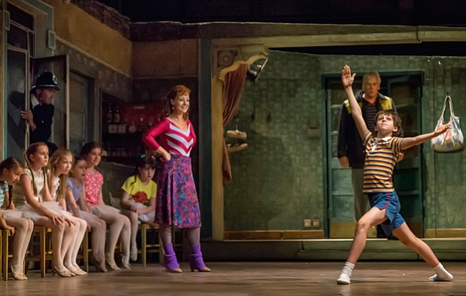

**Task**

Using key drama vocabulary, describe the physical skills of Mrs Wilkinson, Billy and Jackie.

|  |  |
| --- | --- |
| Character | Description of physical skills |
| Mrs Wilkinson |  |
| Billy |  |
| Jackie |  |

As well as physical skills you will need to describe vocal skills.

**Task**

Complete the table below, focusing on what effect certain vocal skills can have.



Analyse

Once you have described the actors use of skills, you will then need to analyse WHY you think they chose to use those skills.

**Task**

Read the descriptions below then complete the analysis. The descriptions are from the scene where Billy’s Dad tries to go back and work in the pits, and Billy’s brother tries to stop him. (If you can’t remember the scene, go back and re-watch it on the shared area)

Jackie (Dad) is played by Deka Walmsley and Tony (brother) is played by Chris Grahamson.

|  |  |  |
| --- | --- | --- |
| Description | Why you think they chose to use these acting skills in this way | Effect on the audience – how did it make you feel? |
| The scene begins with Walmsley facing out to the audience as other ‘scab’ miners gather to go back to work. Walmsley faces the audience, his lip quivering, a lost expression on his face and his head shaking in disbelief over what he is about to do. |  |  |
| Grahamson entered the scene in an extremely powerful way; by climbing over a metal gate and using his vocal skills to scream the word ‘Dad’ at the top of his voice, which subsequently echoed and left a moment for the action to pause. |  |  |

Evaluate

You may think that evaluations can be added onto the end of a question, but to pick up higher marks you need to be evaluating consistently throughout.

**Task**

Read the answer below and identify every time evaluation is included in the paragraph.

*The two actors then stood, motionless, across the stage from each other. Walmsley centre stage-left and Grahamson centre stage-right. This was an effective use of proxemics, having such distance between the two characters, because it signified the emotional distance between them in that moment. The character of Tony clearly believes in the strike, whereas the character of Dad’s belief has wavered and the decision to go back to work has torn the family apart; this is incredibly evident from the use of proxemics seen here and we can sense that should Walmsley’s character make the decision to go back to work, he would be shunned by his family and community and the distance between the two characters would only continue to grow and grow. At this point in the play the characters become ever-more representational of so many families who were torn apart during the miners’ strike as people made the tough decision to cross the picket line. This moment was, as a result, incredibly emotional and tense and the actors gave the audience a clear insight into how the characters’ relationship was at that moment in time.*

**Task**

20 of your 32 marks come from analysing and evaluating, therefore you should be doing it a lot!

Have a go at coming up with synonyms (different words for the same thing) so that you are not repeating yourself over and over!

|  |  |
| --- | --- |
| Analysis  Synonyms for ‘This showed..’ |  |
| Evaluation  Synonyms for ‘This was good…’ |  |

Focus on the scene where Mrs Wilkinson comes into the Elliot household and tells them that Billy wants to audition for the Royal Ballet school. Focus on the character of Tony. Pick two moments where you think he played his character effectively and fill in the table below, using everything you have learnt in the last few pages.

|  |  |  |  |
| --- | --- | --- | --- |
|  | Describe (what did he do? Be detailed!) | Analyse (why did he chose to do it this way?) | Evaluate (was it effective? Why?) |
| Vocal skills |  |  |  |
| Physical skills (movement, gesture, facial expressions) |  |  |  |
| Use of space |  |  |  |

Section C

Have a go at answering the question below, focused on the actor Chris Grahamson, playing Tony. You can discuss another character as well to support your answer. Remember, this is worth 32 marks so you should be spending at least 30-35 minutes on your answer.

Describe how one or more actors in a particular scene of section used their vocal and physical acting skills to create convincing characters. Analyse and evaluate how successful they were in communicating their character to the audience.

You should make reference to:

* Use of voice
* Physical skills
* The actors use of space.

|  |  |  |  |
| --- | --- | --- | --- |
|  | Describe (what did he do? Be detailed!) | Analyse (why did he chose to do it this way?) | Evaluate (was it effective? Why?) |
| Vocal skills |  |  |  |
| Physical skills (movement, gesture, facial expressions) |  |  |  |
| Use of space |  |  |  |