Section B – Blood Brothers

Read through the synopsis of the play on this page. Make sure you have a good understanding of the whole play!





Context

It is very important that you understand the context in which the play is set. Read through the information and complete the tasks in the box on the next page.

* Willy Russell set the play in a working class community in Liverpool between the **1960’s – 1980’s.**
* **Margaret Thatcher** was **Prime Minister** at the time the play was set.

Housing

* In the first act of the play, the Lyons’ and the Johnstone’s are shown to be living close to each other, despite their different levels of wealth. **The Johnstone’s** have probably been living in a **small terraced, rented council house** whereas the Lyons family will have lived in a **larger middle-class house,** likely owned by Mr Lyons.
* The Lyons family move to the countryside during Act 1, as Mrs Lyons wants to move away from the Johnstone’s. At the end of Act 1, Mrs Johnstone is told that she is to move to one of the suburban council estates that were being built. The move away from inner-city areas was a **government plan aimed at improving the quality of housing for the poor**.

Jobs

* In the 1970’s and early 1980’s Liverpool suffered a **great economic decline** (which some blamed on Margaret Thatcher)
* **This led to many lost jobs.** Russell refers to this in the song **‘Take a letter Miss Jones’** when Mr Lyons fires a number of employees as ‘an unfortunate sign of the times.’
* At some points, the unemployment rate was as high as 50%.
* Sammy is already **‘on the dole’** at the start of Act 2 and we later see Mickey lose his job and go on the dole as well, leading to the two brothers committing the robbery which lands them both in prison.
* The **recession** heightened the differences between the working class and middle/upper classes.

Education

* At this time, all children took the **‘11+’** an exam which would decide if you would go to a Grammar school or a secondary modern.
* Linda and Mickey (like the playwright Willy Russell himself) attend a **secondary modern**, a state school for students who did not pass their 11+.
* Edward attends a **private boarding school,** which would have cost a lot of money.

**6.1 Design**

**You will be asked to design an element of performance support for a key extract in the play. This MUST show your knowledge of the context of the play (4 marks)**

Have a go at answering the following questions. Remember, you MUST refer to context.

1. You are designing a costume for Mrs Johnstone to wear in the first Act of the play. The costume must reflect the context of Blood Brothers, set in a working class community in the 1970’s. Describe your design ideas for this costume.
2. You are designing a set for the start of Act 1. The set must reflect the context of Blood Brothers, and highlight the differences between the lower and middle classes.

**Task**

Research the following elements. You could find pictures to support your research.

* Clothing in 1960’s – 1980’s (popular colours/fabrics/styles)
* Housing in the 1960’s – 1980’s (council houses like the Johnstone’s and wealthier houses like the Lyons’) Also consider the style of furniture each family would have in their house and what the surrounding area would look like

Interpretation of character

Read through the interpretation of Linda below.



**6.2 Key line of text**

**You will be asked to describe how you would use your vocal and physical skills to deliver a line from the key extract (8 marks)**

Have a go at answering the following questions. Remember, you MUST refer to both vocal and physical skills AND explain the effect you want to create.

These questions are focused on the scene where Mickey and Eddie meet for the first time

1. You are playing the role of **Edward.** *Describe* how you would use your vocal and physical skills to perform the line below *and explain* the effects you want to create.

**“You say the most smashing things! Will you be by best friend?”**

1. You are playing the role of **Mickey.** *Describe* how you would use your vocal and physical skills to perform the line below *and explain* the effects you want to create.

(When answering the question from Edward ‘Don’t you know what a dictionary is?’)

**“‘Course I do … It’s a, it’s a thingy, innit?”**

**Task**

Using the same format as above, complete the character interpretation of Edward. 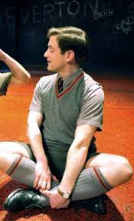

Voice:

Costume:

Effect on audience:

Themes

There are a variety of themes explored in Blood Brothers.

**Task**

For each theme identify characters, scenes or even quotes which link to this theme.

|  |  |
| --- | --- |
| Superstition | Class and social inequality |
| Nature vs nurture | Friendship |
| Death and violence | Comedy |

Use of space

Use of space is an important thing to think about throughout the exam, but especially in question 6.3 which will ask you specifically about it.

For each picture, look at the space used between the characters and explain what you think this says about the characters and their relationships.

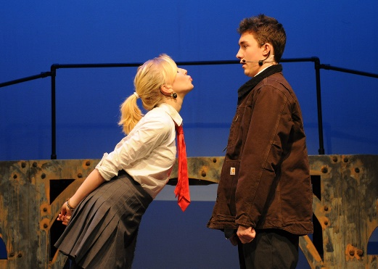

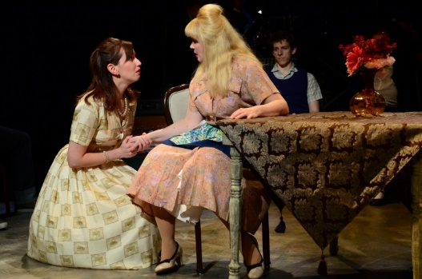

**6.3 Shaded extract**

**You will be asked to focus on a shaded part of the key extract and imagine you are playing one of the characters. You will describe how you would use your theatrical skills, including your use of space, to create a particular intention on stage (12 marks)**

Read the extract below and then have a go at answering the question

**Mickey** Yeh. Yeh, an’ it’ll really help me to get a job if I know

what some soddin’ pygmies in Africa have for their dinner!

*The class erupts into laughter.*

**Teacher** (*to class*) Shut up. Shut up.

**Mickey** Or maybe y’ were thinkin’ I was lookin’ for a job in

an African restaurant.

**Teacher** Out!

**Linda** Take no notice, Mickey. I love you.

**Teacher** Johnstone, get out!

**Linda** Oh, leave him alone, you. Y’ big worm!

**Teacher** Right, you as well…out…out…

**Linda** I’m goin’…I’m goin’…

**Teacher** You’re both suspended.

1. You are performing the role of Linda. Focus on the shaded part of the extract. Explain how you and the actors playing Mickey and the Teacher might use the performance space and interact with each other to **create comedy** for your audience.

Developing your interpretation of a character

As the questions in the exam progress, you will be asked to further develop your interpretation of a character.

In 6.4 you will need to explain how you will play your character in the extract given AND in the rest of the scene.

**Task**

Read and complete the table below.

|  |  |  |  |
| --- | --- | --- | --- |
| **Character** | **First key moment** | **Second key moment** | **Third key moment** |
| **Mrs Johnstone** | *First scene with Mrs Lyons* | *When Mrs Lyons attacks her* | *At the end of the play when Mickey confronts Edward* |
| **Interpretation** | She is an open, warm character who is struggling to get by. She tries to make the best of a bad situation. |  |  |
| **Important line** | “It’s such a lovely house, it’s a pleasure to clean it.” |  |  |
| **Physical skills** | She is respectful to Mrs Lyons and wouldn’t sit in her presence. She keeps working while she is speaking to her. She would be smiling as she is genuine in what she is saying. |  |  |
| **Vocal skills** | Strong, Liverpool accent and warm, friendly tone. |  |  |

Focus on the scene where Mrs Lyons asks Mrs Johnstone to give her one of the babies.

**Task**

In this question, you will be asked to play the role of Mrs Johnstone. Read the plan below.



**6.4 Wider interpretation of a character**

**You will be asked to imagine you are playing a specific character in the play. You will be asked how you would use your theatrical skills to interpret this character. You MUST reference other sections in the play during this question, not just the key extract (20 marks)**

Using the plan above, and the table you completed on the previous page, have a go at answering the question below.

You are playing the role of **Mrs Johnstone**. Describe how you would use your acting skills to interpret Mrs Johnstone’s character in this extract and explain why your ideas are appropriate both for this extract and the play as a whole.