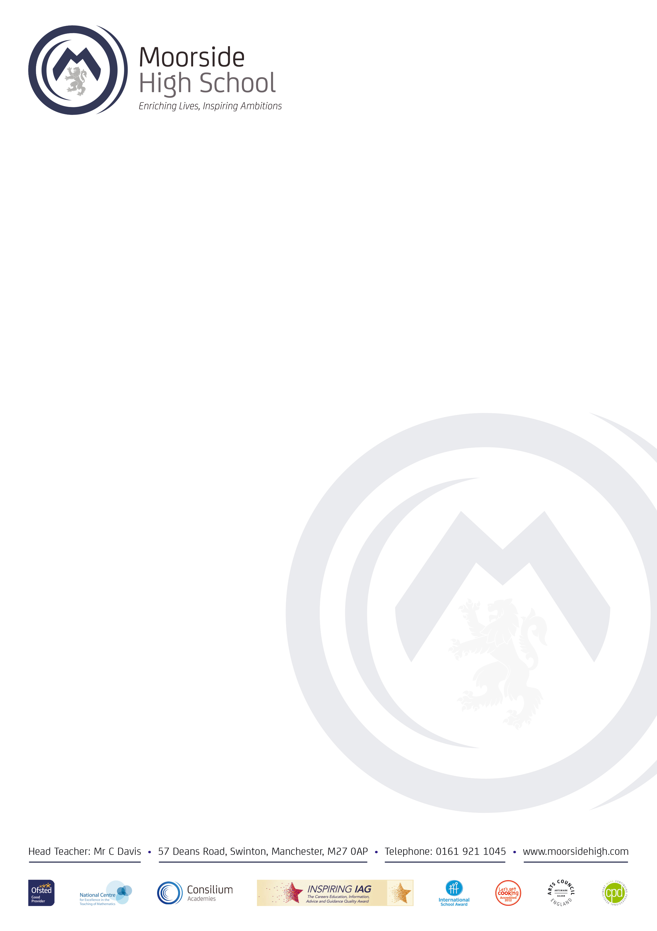
Friday 14th May 2021

Dear Parent/Carer,

Firstly, can I thank you for the support you have already given the school and myself, with regards your child’s Drama course. We fully appreciate how challenging the situation has been over the past 12 months and we want to ensure that students have as much evidence and support as possible, to ensure a TAG grade can be provided that truly reflects where your child is currently working.

As part of the evidence being used towards the GCSE Drama TAG, the students will be completing a ‘Live Theatre Review,’ on ‘Billy Elliot The Musical.’ All Year 11 students have watched and studied this play in depth throughout the course. For the assessment question, they only need to focus on one scene, which we will be revising in detail in class. However, to ensure students feel completely comfortable and confident with the play as a whole I have organised a viewing evening on Tuesday 18th May at 3:15pm in the Performance Hall. This is an opportunity for the students to watch the whole play, uninterrupted. The viewing will finish at approx. 5:30pm.

If your child cannot attend this evening, but would like to review the play as a whole, it is available via a One Drive link which has been emailed to them.

If you have any further questions, please do not hesitate to get in touch.

Thank you for your continued support

Kind regards,

Mrs Ross
Head of Drama

